ChatGPT- Based Storytelling
Screenshots

ChatGPT- Based Storytelling Document
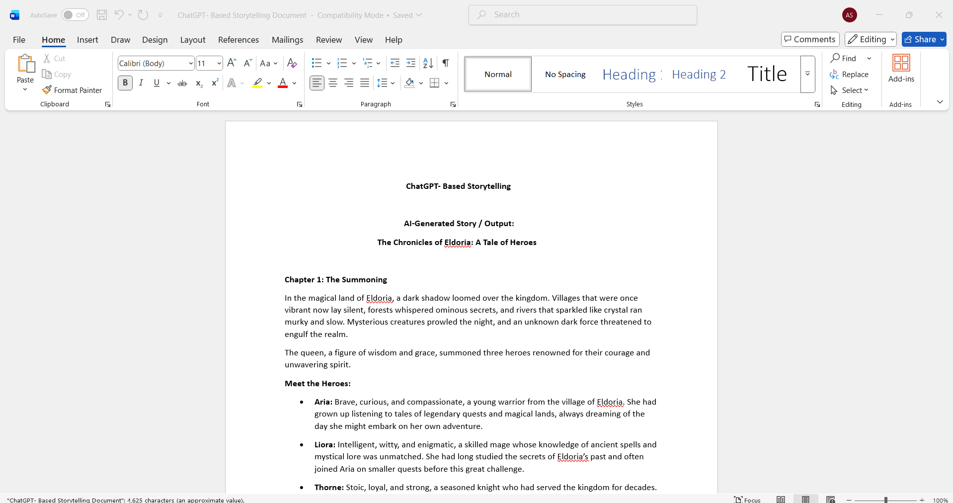
ChatGPT- Based Storytelling WriteUp
